Membership Form

Name:

Email Address:

Tel:

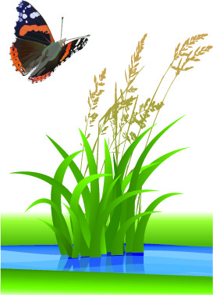
Declaration: By completing the above, I accept that BaNG will store and use this information for the purpose of communicating with me about group events and activities. BaNG will not pass the information to any other organisation without my consent.

Membership Fee - £10 per annum (from 1 Jan)

BACS
- Acc Name: Benson Nature Group
- Acc No: 23590360
- Sort Code: 30-91-91

Cheque/Cash: Send or deliver with this form to Fiona Brown,
26 Passey Crescent, Benson, OX10 6LD or fi.brown@tiscali.co.uk

